**Apple introduces Tap to Pay on the iPhone, which will be available to US merchants later this year.**

Taking the hassle out of the payment process

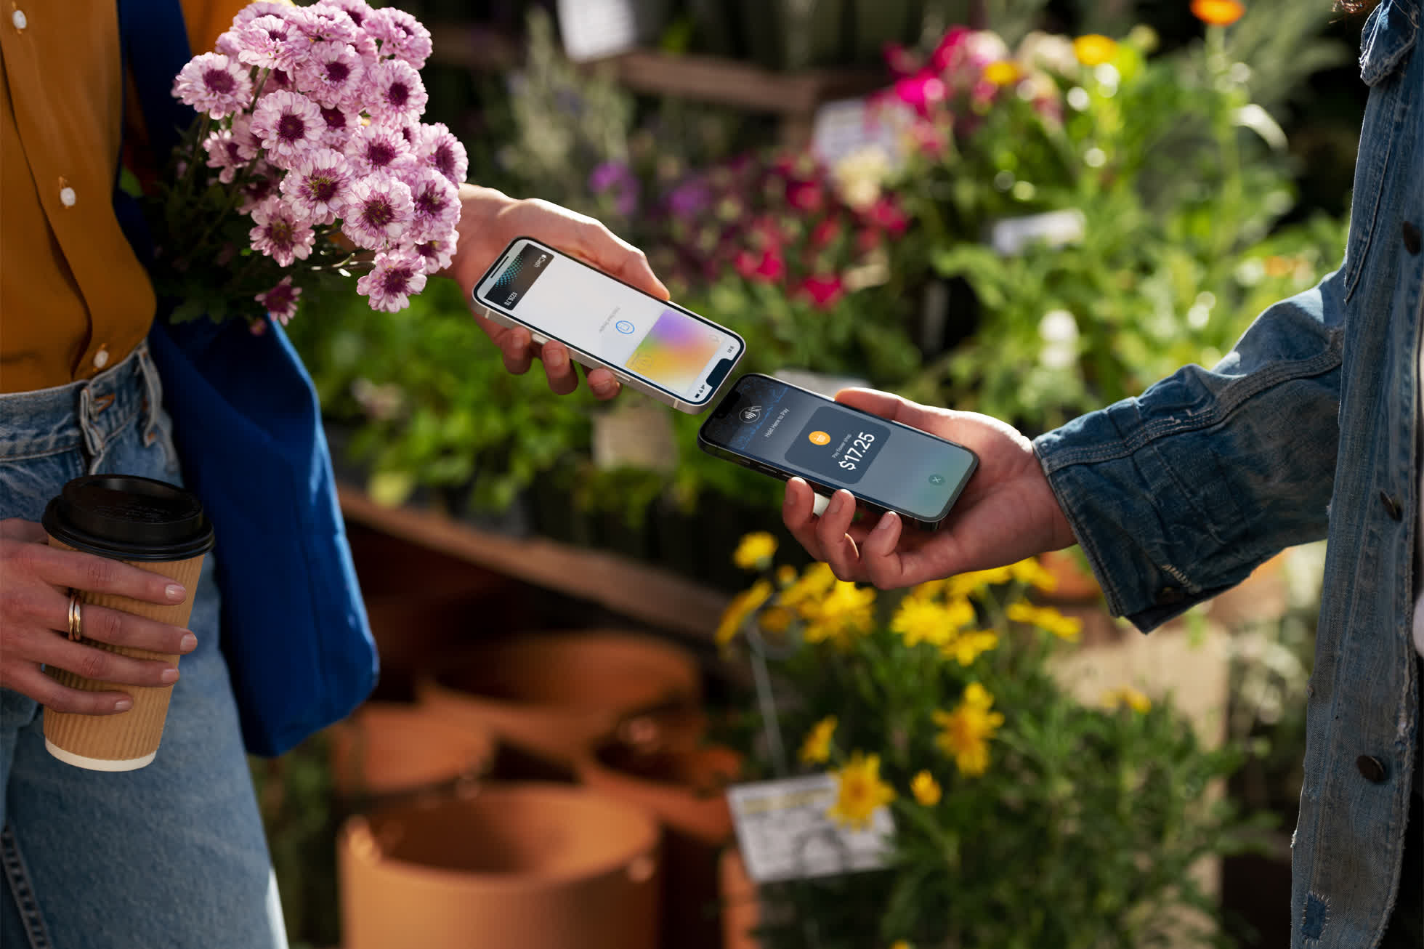

So, what exactly happened? Once again, the rumour mill was correct. Apple has announced a feature that turns iPhones into mobile payment card terminals without requiring any additional hardware or third-party devices, less than two weeks after reports said it might.

With the new Tap to Pay functionality, merchants will be able to accept Apple Pay, contactless credit and debit cards, and other digital wallets by simply tapping their iPhone. Stripe will be the first payment platform to offer Tap to Pay on iPhone to clients, according to Apple, with more partners expected to join later this year.

Apple Store locations will, of course, accept the new payment option.

Merchants will be able to take contactless payments using an approved iOS app on iPhone XS or later smartphones once the service is launched. To complete the purchase via NFC technology, the customer must hold their iPhone, Apple Watch, contactless credit or debit card, or other digital wallet near the merchant's iPhone during checkout.

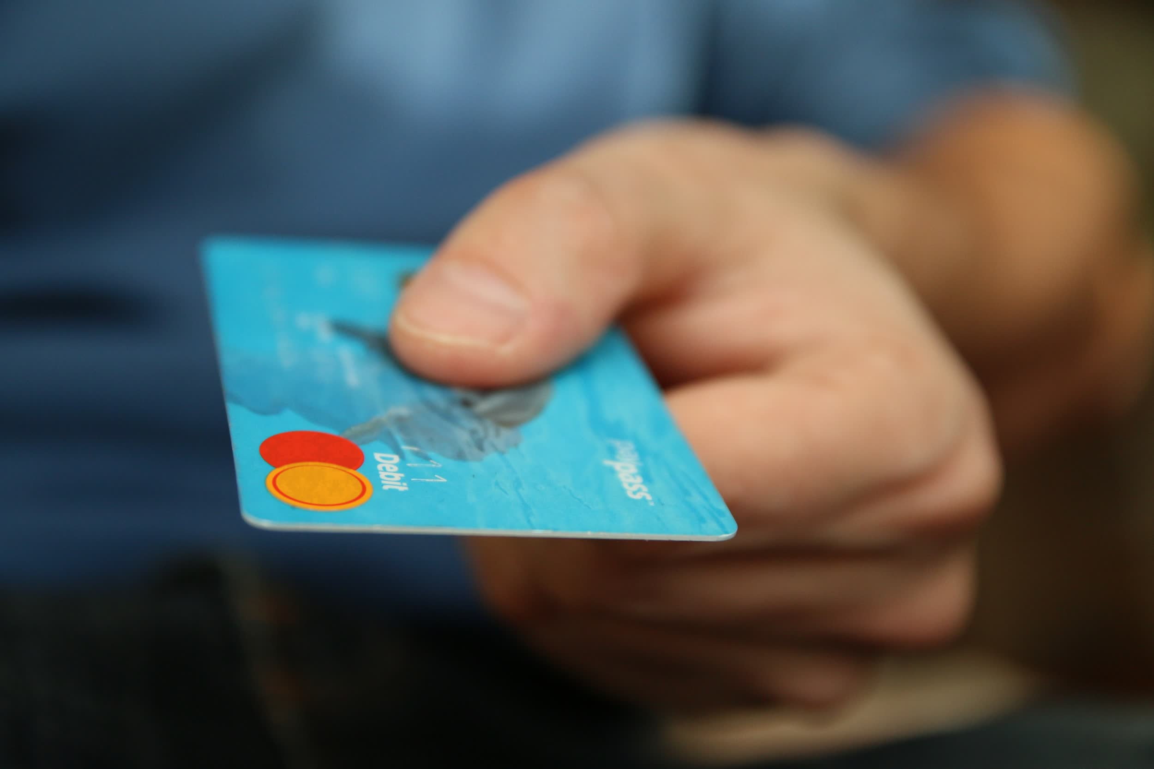

The transaction will be encrypted and processed using the Secure Element, which is the same technology used by Apple Pay. As a result, Apple has no idea what is being purchased or who is making the purchase.

Apple Pay is already accepted at over 90% of businesses in the United States, so persuading merchants to accept purchases using iPhones won't be difficult.

In a forthcoming iOS software beta, Apple will provide Pay on iPhone capability for developers to use in their SDKs.